Project Design Phase
Solution Architecture

Date | 15 February 2026
Team ID | LTVIP2026TMIDS72262
Project Name | Importing & Securing Data in Servicenow
Maximum Marks | 4 Marks

Solution Architecture:
The solution architecture for the Importing & Securing Data in ServiceNow project focuses on enabling secure, automated, and validated data imports into the ServiceNow platform. The architecture ensures data integrity, role-based access control, encryption of sensitive information, and audit tracking while integrating external data sources through secure APIs or scheduled imports.
The architecture follows a structured multi-layer approach that separates user interface, application logic, data storage, integration mechanisms, and workflow automation to ensure scalability, security, and maintainability.
Solution Architecture Diagram:

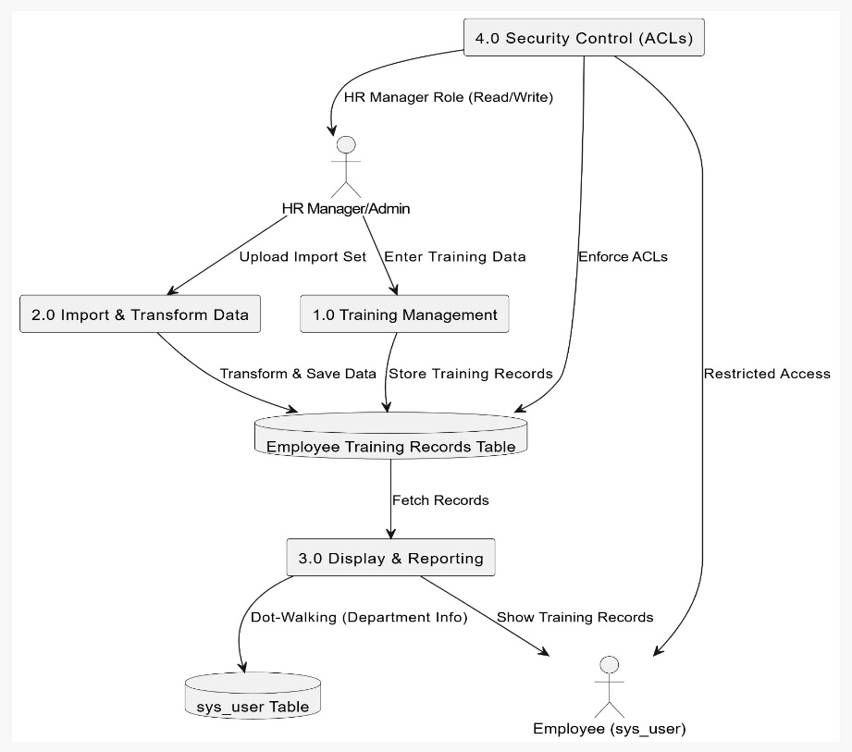
Figure 1: Architecture and data flow of the application

